1. Loop through and display a link for each hero listed in the heroes property on the dashboard component
   1. Use an h4 tag to display the heroes name
   2. Wrap the name in a div with classes module and hero
   3. Wrap the div in a link that uses a router link to the detail view and passes the hero id property
   4. Result should display as follows:
      1. 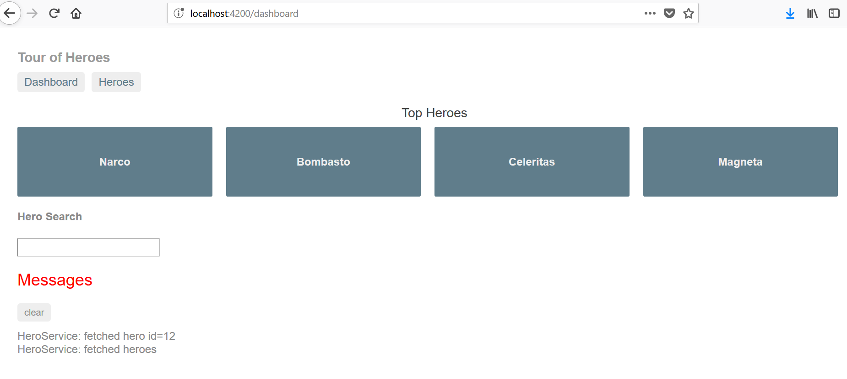
      2. Each hero box should be clickable, and link you to the details page of the respective hero
2. Create a name property and bind its input to the Hero’s name in the details component
   1. Use an input and bind it to the name property
   2. Result should display as follows:
      1. 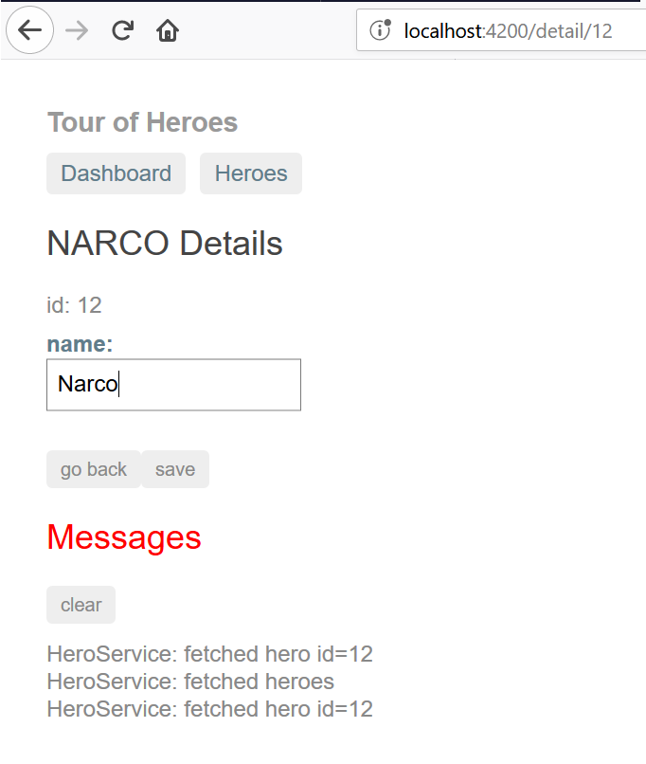
      2. Hero Name label should update as text is typed into the input